Equality Impact Assessment (EQIA) Template

Section 1: Details of the policy/practice/project
Information required | Enter information below
Department/Team responsible | Learning and Skills Development
Name of Policy, Practice or Project being assessed | WOODS Development Programme
Purpose and anticipated outcomes | To develop new Assistant Woodland Officers and Woodland Officers to equip them with the skills, knowledge and tools required by Scottish Forestry to ensure consistent delivery.  Outcomes  - By the end of the programme the AWO/WO should meet the competency requirements for their role. AWO/WO will be competent and confident  - Through participation in the WOODS programme AWO/WOs have a successful onboarding experience  - The WOODS Programme will positively contribute to overall conservancy productivity in the long term.. We will ensure the quality of the programme is continuously evaluated
Is this a new or existing Policy, Practice or Project? | New, although we did run an ‘interim’ programme to support AWO/WO who started during Covid to support them
List of participants in Equality Impact Assessment process | Nicola Steven – Learning & Skills Development Manager  Judith Hamilton – Learning & Skills Development Officer  Ella Hashemi – Equality, Diversity and Inclusion Manager
Date Assessment started | 14.2.23
Completion date | 18.4.23
Who is likely to be affected?  E.g. employees, visitors, contractors, women, men, young people, older people, people with disabilities etc. | AWO and WOs and Line Managers  Training Facilitators

Section 2: Collecting information
What evidence is available about the needs of relevant groups? Please consider demographic data, including census information, research, consultation and survey reports, feedback and complaints, case law, others knowledge and experience. Please refer to the list of evidence on the EqIA page of the intranet.
Details | Source of evidence
Whole workforce demographics as of March 2023  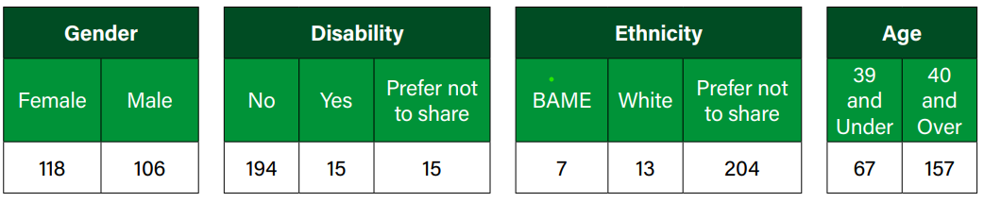  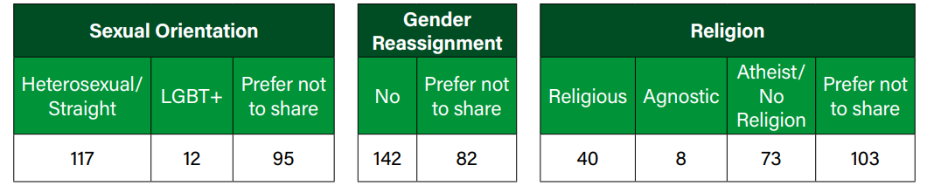 | Mainstreaming Report
L&D course attendance  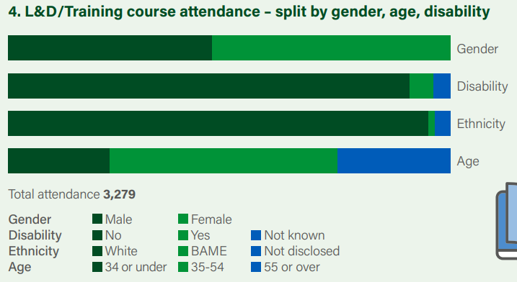 | Mainstreaming Report
Access to L&D  Scottish Forestry as a whole  Access to L&D  Conservancies  Key  Green – percentage positive  Grey – percentage neutral  Pink – percentage negative | People Survey 2022
Themes from Review  - Joining instructions include a statement requesting learners to contact L&SD if they require support.  - Learners want more flexibility in how they learn to facilitate home life e.g. join virtually rather than face to face  - Blocks of Face to Face Training can be difficult for everyone to attend to balance other commitments  - Systems training can be self-directed rather than classroom based  - Where possible, training materials available at least a week before hand to enable learners to make appropriate adjustments e.g. dyslexia or autistic  - Need to ensure learning is accessible for staff dialling in online.  - However face to face interaction is key to put learning into context  - Facilitators have joined both virtually and in person, meaning they can juggle workload, travel and other requirements, however we need to support facilitators to deliver sessions remotely and in a hybrid method to ensure everyone is included, making effective use of technology and Teams as a delivery method  - Facilitator delivery skills and styles need to ensure meeting different learning styles and using appropriate language | Review by participants and facilitators of ‘Interim WOODS’ Programme, facilitated by L&SD
‘We want to create and maintain a skilled workforce to meet the demands of the future, empowering all staff to choose the direction of their own career. Encouraging underrepresented groups to aspire to become leaders and ensuring they have the skills required to do so as well as supporting young people to build their forestry career. We have identified that we need a structured, consistent and proactive approach to Learning and Skills Development to achieve our ambition’  ‘By adopting this structured, consistent and proactive approach to Learning & Skills Development, Scottish Forestry is committed to developing Learning and Skills Development systems and processes which will support Leaders, Managers and staff to identify development needs and meet their aspirations. These will be easily understood and accessible to all, underpinned by our values and linked to the employee development journey detailed below.’ | L&D Strategy
Best Practice L&D Delivery  3 Tips for Inclusive Virtual Training Events - Training Industry  Inclusive Training: How to Build Inclusive and Accessible Online Training Programs for Employees (talentlms.com)  15 Best Practices And Virtual Training Tips For Trainers | EdgePoint Learning  Six Steps to Creating Inclusive Training (rw-3.com) | Google
Learning and Development – Evolving Practice  https://www.cipd.co.uk/knowledge/strategy/development/evolving-practice-factsheet#67230 | CIPD

From your research above, if you have you identified any gaps in evidence, enter the details of the gaps below
For staff we do not have 100% declarations on protected characteristics which is a gap in evidence.
There is a gap in the knowledge and skills of our facilitators in delivering to a diverse audience and making an effective use of technology to enable a more flexible approach
We do not have a breakdown on interim program protected characteristics.

As appropriate, please describe below, the consultation/engagement undertaken, including details of the groups involved and the methods used
Feedback is gathered from participants on the ‘Interim’ WOODS programme on a monthly basis both in person and via surveys
Project working groups – Delivery and Development colleagues who are directly involved in the development of a project, meeting at least monthly to discuss any practical issues related to the projects.
Improvement Development Programme People and Ways of Working Steering group – Senior colleagues from Delivery, Digital, Future Working and Programme Management. Meets monthly discuss issues and provide policy steers for relevant projects.
The L&SD Officer met with the facilitators before and after their delivery to go through current learnings and to help adapt delivery to take this into account and gather feedback

Detail below if there are any other groups to be consulted
None

Section 3: Impacts
Has the research and consultation identified any potential for impacts on those with the following protected characteristics:
Protected Characteristic | Potential Impact (yes or no) | Explain
Age  E.g. older people, children including looked after children, young people including care leavers | Yes – positive | There is a shortage of skills in the forestry sector, therefore recruitment criteria has been amended for the AWO and WO roles to attract a wider variety of people such as people changing careers or returning to work or school leavers. The WOODS development programme is designed for those people who may not have a forestry background.  The WOODS programme is designed to be accessible for all either through the facilities, technology and materials we use. The design is a mix of self-directed, eLearning, face to face delivery and support in the workplace to embed the skills. There is online support for everyone for example, if they have not used MS Teams before.  The newly launched Induction SharePoint site gives support to new members of staff and their line managers to help them settle into SF and sign post to a myriad of resources and support
Disability  E.g. long term mental health conditions, neurodiversity, physical impairments | Yes both positive and negative | The WOODS programme will be delivered through a variety of measures such as on the job, mentoring, eLearning and face to face with the option to attend these virtually.  Content will be accessible and available in different formats and accessibility of locations will be taken into account to ensure they are accessible for all learners  When designing eLearning content we will ensure that the platform used has accessibility technology and follow the SG Digital Learning Accessibility Checklist to ensure we meet WCAG 2.1.  Powerpoint presentations will also follow Microsoft accessibility checker guidance which takes into account alternative text for participants using screen readers, considers text contrast for dyslexic/ visually impaired participants  Creating accessible PowerPoint presentations  Content will be available from facilitators prior to the module to allow participants adequate time for appropriate adjustment.  All joining instructions that are sent out to participants and have an ‘Additional Requirements’ statement as detailed below in Section 4 and we are committed to implementing this for all learners  There are practical elements of the programme that require participants to be out on site in a forest, which will not be accessible for someone with some types of physical disability. We pro-actively ask training participants about any adjustments they have and we will ensure that any general workplace adjustments carry into the WOODS programme.
Gender reassignment  Where a person is living as a different gender to that at birth | No | We have identified the need to ensure we use inclusive language across different characteristics therefore the L&SD team will put together a briefing or Train the Trainer session, depending on experience, to work with facilitator so understand different learning styles and ensure exercises and language are appropriate and inclusive.  Very few of the training facilities have gender neutral toilet facilities
Pregnancy and maternity  Including breastfeeding | Yes – both positive and negative | The flexibility of the programme could be beneficial e.g. learn at own pace with elearning options and can choose to attend face to face sessions or virtually  As part of the design we are identifying what learning is best suited to self-directed/e-learning which should be beneficial and which training needs to be practical.  However, at the minute the plan is that face to face sessions will be run annually, due to availability of trainers and the fact that some training is seasonal. Therefore a parent maybe disadvantaged if they have childcare commitments or if someone is on maternity leave they may miss some modules and have to wait a year to catch up. However, we will prioritize them to ensure they can attend the training when it is next available.
Race, ethnicity, colour, nationality or national origins  Including gypsies or travellers, refugees or asylum seekers | No | There is no evidence to suggest the WOODS programme will have an impact on race, ethnicity, colour, nationality or national origins
Religion or belief  Including non-belief | No | There is no evidence to suggest the WOODS programme will have an impact on religion or belief
Sex/Gender | Yes - positive | As women are generally the main carers, the flexibility of the programme e.g. self-paced eLearning and the option to attend virtually mean that other commitments can be fitted around the development programme
Marriage and civil partnership | No | There is no evidence to suggest that the WOODS programme will have an impact on marriage and civil partnership
Sexual Orientation | No | There is no evidence to suggest that the WOODS programme will have an impact on sexual orientation

Is there any evidence that the policy may result in any less favourable treatment, discrimination, harassment or victimization as detailed below:
Potential outcome of the policy | Delete as appropriate | If yes, give details of the potential outcome and any project modifications to mitigate the risk
Result in less favourable treatment for particular groups | No | Potentially parents or staff on maternity / paternity / shared parental leave as some sessions will only run either once a year (due to resources) or at a certain time of year due to seasonality. We will therefore ensure that these members of staff are prioritized when the session runs again and are provided support in the workplace.  Those staff who may have a physical disability will be negatively impacted as they may not be able to attend practical elements on site. We will therefore pro-actively ask participants about any adjustments they have and we will ensure that any general workplace adjustments carry into the WOODS programme
Give rise to direct or indirect discrimination | No
Give rise to unlawful harassment or victimisation | No

Section 4: Meeting our General Equality Duty
Enter below which aspects of the Policy, Practice or Project seek to eliminate unlawful discrimination, harassment and victimisation
- The WOODS development programme is open to all new AWOs and WOs and will link to our Learning and Skills Development strategy to ensure it aligns
- The programme will take a flexible approach to its design meaning there will be a mix of self-directed eLearning, webinars, practical face to face sessions, mentoring and on the job learning to embed the skills. There will also be a hybrid option available for face to face delivery
- The design of learning materials will follow SG and professional guidelines to ensure accessibility
- Content will be available from facilitators prior to face to face delivery to allow for adjustments
- All joining instructions will have and ‘Additional Requirements’ statement as described below
- When identifying training venues we will ensure that they are accessible to all and investigate gender neutral facilities
- Facilitators will receive support and guidance from the L&SD team to ensure the learning is fit for purpose and inclusive and they have the skills to deliver it in this way

Enter below which aspects of the Policy, Practice or Project seek to advance equality of opportunity between people who share a relevant protected characteristic and those who do not
All materials will be designed to ensure that they are accessible to all and adhere to guidelines (SG Digital Learning Checklist / Microsoft Creating Accessible PowerPoint Presentations) and best practice detailed above
All joining instructions will include the following statement about adjustments:
‘Additional Requirements
FLS and SF recognises that everyone is different, and values the individual contribution that people can make. We therefore want your training experience with Learning & Development (L&D) to be as beneficial and enjoyable for you as possible.
If you have any additional support needs or think you may require any adjustments in order to attend or participate fully, please contact the L&D Team to discuss your requirements. If you are unable to contact us direct please ask a friend or colleague to do so for you. All details provided will be held in the strictest confidence.’

Enter below which aspects of the Policy, Practice or Project seek to foster good relations between people who share a protected characteristic and those who do not
The face to face elements of the WOODS programme will provide participants time to get to know each other and build relationships that will help them throughout their time in Scottish Forestry, getting to know and working with people who may have a protected characteristics.

This is underpinned by our BRAVE Values and we run a specific session on this at the induction session at the start of the WOODS programme. Our Values are :-

Be Professional
Respect Others
Act with Integrity and Honesty
Value Teamwork and Collaboration
Encourage Innovation and Creativity

More information can be found on Saltire SF Values and Behaviours

Section 5: Outcome of the assessment
Outcome of the assessment on the Policy, Practice or Project | Enter detail below
No major change
Adjust the Policy, Practice or Project | As per adjustments within this EqIA
Continue to Policy, Practice or Project
Stop and remove the Policy, Practice or Project

Detail below recommendations, including action required, to address any negative impacts identified

Section 6: Monitoring
Describe below how you will monitor the impact of this Policy, Practice or Project
E.g. performance indicators used, other monitoring arrangements, who will monitor progress, criteria used to measure achievement of outcomes etc.
- AWO/WOs are competent and confident (assessed against AWO/WO competency framework and linked to Induction, Probation and Performance and Development processes)
- AWO/WOs are progressing through the programme as planned with quarterly check ins with line manager. L&SD will develop an approach to quality assure this through the design of the programme.
- Review the WOODS programme at the end of year 1 in May 2024

When and how is the Policy, Practice or Project due to be reviewed?
Annually every January

L&SD will carry out a stage 1 evaluation of each module on a quarterly basis and a full evaluation of the effectiveness will be carried out annually. This will be through a mixture of surveys, interviews and benchmarking against our success factors detailed above.

Section 7: Sign off
Required information | Enter information below
Date sent to Equality and Diversity Manager | February – April 2023
Comments from Equality and Diversity Manager | Not needed as involved in the assessment
Date signed off by Equality and Diversity Manager | 17.04.2023

Details of Senior Manager who has signed off this Equality Impact Assessment | Enter information below
Name | Zahid Deen
Title | Head of Operational Services and Transformation
Date approved | 18.04.2023

Please send this completed and approved Equality Impact Assessment to:
Ella Hashemi, Equality, Diversity and Inclusion Manager, Forestry and Land Scotland

