Joint Working Agreement
between
Scottish Forestry, Historic Environment Scotland, NatureScot,
and Scottish Environment Protection Agency

- Context

Scottish Forestry (SF) is an executive agency of the Scottish Government as set out in the Forestry and Land Management (Scotland) Act 2018 and is responsible for regulating forestry activities and supporting the delivery of Scottish Government’s priorities for Scotland’s forests by providing guidance, advice, and incentives in accordance with the UK Forestry Standard. With a duty on Ministers for Sustainable Forest Management, SF also advises Ministers on forestry policy and leads on the delivery of Scotland’s Forestry Strategy (2019-2029).

Historic Environment Scotland (HES) is a charitable non-departmental public body whose statutory functions are set out in the Historic Environment Scotland Act 2014. Its primary purpose is to investigate, care for and promote Scotland’s historic environment and to manage its collections as a national resource for reference, study and research. HES is the lead public body in protecting, understanding and sharing Scotland’s historic environment for today and tomorrow.

NatureScot is a non-departmental public body, established under the Natural Heritage (Scotland) Act 1991. It is the lead public body responsible for advising Scottish Ministers on all matters relating to the natural heritage, with responsibilities for the conservation and enhancement of the natural heritage, and for fostering its enjoyment, understanding and sustainable use. Its remit covers biodiversity, landscape, access rights, and the conservation, control and sustainable management of deer in Scotland.

Scottish Environment Protection Agency (SEPA) is a non-departmental public body of the Scottish Government established under the Environment Act 1995 and Regulatory Reform (Scotland) Act 2014. Its primary role is to protect and improve Scotland’s environment, to ensure natural resources and services are used sustainably and contribute to sustainable economic growth. Its remit covers monitoring air, land and water media to advise government, industry and the public on environmental responsibilities and best practice. Partnership working with other agencies, organisations and policy makers to increase environmental understanding and build consensus on environmental priorities.

This agreement supersedes all other previous individual Concordats or Joint Working Agreements between Scottish Forestry and these agencies. It will formally be reviewed in 2027.

Our agencies have also agreed a joint statement on climate change.

- Purpose

This agreement explains how Scottish Forestry and their Statutory Consultees will work together effectively to deliver forestry alongside policies and legislation pertaining to historic environment, biodiversity, landscape and water. The aim is to promote a more integrated approach to creating and managing Scotland’s forests and woodlands ensuring this takes account of other important factors and assets whilst contributing to economic growth, social wellbeing and environmental improvements.

This agreement also promotes good working relationships, better mutual understanding, stronger cooperation, and clear channels for advice and consultation on policy development and the implementation of forestry consents and approvals.

- General principles

- All parties are part of a wider family of public bodies who strive to deliver the Scottish Government’s programme for government in efficient, joined up ways.
- In particular we work closely together to deliver, and influence others to deliver, government priorities for forestry, climate change, water, the historic environment, biodiversity and landscape; bringing our respective specialisms together.
- We strive to deliver and protect tree-planting, woodland regeneration, woodland management and deer management to tackle the twin challenges of climate change and biodiversity loss, and safeguard and enhance the wider environment as per Scotland’s Forestry Strategy 2019-2029.
- We will work together in a joined-up manner that maximises efficiency for applicants and all organisations, and provides a clear and consistent service across Scotland.
- In forestry casework, NatureScot, SEPA and HES have an advisory and statutory role to SF who is the regulatory authority for forestry Environmental Impact Assessments (EIA) and felling permissions, and the Competent Authority under the Habitats Regulations.
- To improve efficiency and focus inputs at the earliest stages of proposals, all parties will commit to preparing and updating appropriate guidance in order to deliver current policies on biodiversity and climate change, with reference to the UK Forestry Standard requirements and guidelines.
- We will offer and share training on key issues, and all parties offer to develop further standing advice which can be embedded within, or linked from, documents the forestry sector already use.
- In general, Statutory Consultees will focus on guidance, standing advice and early engagement. Inputs to individual applications will usually be restricted to those detailed in the annexes.
- We expect applicants and agents developing forestry proposals to use online advice and guidance to identify key opportunities to protect and where appropriate enhance protected areas and other historical and natural assets, prior to any requests for advice from Statutory Consultees. Requests for consultee advice should be in line with the case types set out in the Annexes below, and should be copied to SF.
- We will collaborate in commissioning research, policy and regulation development, and agreeing best practice.
- We will promote the sharing and interpretation of relevant data, knowledge and experience about the environment, water, forestry and the historic environment.

Refer to attached annexes for details of agreement between Scottish Forestry and Statutory Consultees.
- Annex 1 – Historic Environment Scotland
- Annex 2 – NatureScot
- Annex 3 – Scottish Environment Protection Agency

- Resolving differences

We will seek to maintain regular liaison between operational staff of each organisation.

Where any differences of view between any of the Statutory Consultees and SF in relation to areas of operational delivery covered by this agreement arise, they should, in the first instance, be discussed locally and promptly. If issues cannot be resolved between area offices / casework officers for each organisation, they will be escalated, as required, to:
- Head of Planning, Consents and Advice Service, HES
- Deputy Director of Sustainable Growth, NatureScot
- Head of Energy, SEPA
- Head of Operational Delivery, Scottish Forestry
Annex 1 – Historic Environment Scotland (HES)

- Joint working between SF and HES

Staff in both organisations are encouraged to undertake the following activities at all relevant levels within their organisations:
- seek to improve planning and management of designated historic assets at strategic, landscape and site levels, including regular local liaison. Such liaison will include consultation on woodland creation proposals and forest management plans with regard to the identification, protection and management of significant designated historic environment assets;
- Seek to promote the protection, restoration and rejuvenation of trees, woodlands and forests in Scotland’s designated designed landscapes (reference SF Practice Guide Conserving and managing trees and woodlands in Scotland’s designed landscapes).
- Work closely together to support delivery of Scotland’s Forestry Strategy 2019-2029. HES will support this strategy in part by providing up-to-date spatial information through its website as outlined below.

Historic Environment Scotland provides up-to-date designations information on the HES Portal. Users can download current designations spatial data and conduct map searches. Map searches can also be made on the Pastmap website. SF should obtain current designations data where needed from these sources and HES will provide advice on request. There is an option to access live designations data for use in geographical information systems.

In addition, HES provides incomplete information about known site extents on its Canmore Mapping Layer. This can be downloaded from the Canmore website Data Downloads page. To access this data, SF staff and applicants/land managers should go direct to the website to access the latest information. HES staff will continue further mapping of known historic features, adding this to the Mapping Layer. Manual sharing of information is not usually helpful and data shared manually can quickly become out of date.

It is important to note that in line with UKFS, the primary source for non-designated historic environment assets should be the local authority Historic Environment Records (HERs). They are curated by archaeology services that can provide specialist local advice on non-designated assets in their areas. Land managers undertaking woodland creation or forest planning should obtain up-to-date information from HERs. The known site extent areas on Canmore are very incomplete and it is critical that land managers consult HERs, where they can usually also access specialist advice. UKFS confirms that “HERs represent the major information source for understanding the local historic environment.”

Provision of spatial information via HES websites assists with delivery of SFS Implementation Plan.

- Forestry case types on which HES advice will be sought by SF

With respect to forest and woodland casework with an historic environment interest:
- SF staff will follow an approach of timely early engagement on forestry proposals with HES. In return, HES staff will similarly provide timely advice on the protection and management of relevant designated historic assets and their setting (reference SF [FCS] Guidance Note The provision of archaeological information and advice in Scotland to meet the UKFS);
- SF and HES staff will liaise with the Local Authority Archaeology Services (ALGAO Scotland) to ensure that advice on the historic environment is sought in line with UKFS Historic Environment requirements and guidelines;
- SF and HES staff will work together to train and support SF Woodland Officers to make confident and appropriate decisions to ensure that casework meets the UKFS Historic Environment requirements and guidelines, particularly with respect to the effective use of online datasets;
- SF will consult HES on the forestry case types noted in the table below whenever there is potential for impacts on Historic Environment Assets within HES’ remit and their settings:
  - Scheduled Monuments
  - Category A-Listed Buildings
  - World Heritage Sites
  - Inventory of Gardens and Designed Landscapes sites
  - Inventory of Historic Battlefields sites
  - Marine Protected Areas

Forestry case type | SF will consult HES if the proposal could affect an asset within HES’ remit or its setting
Woodland creation pre-application (due diligence) | Yes
Woodland creation FGS applications & associated management | Yes
LTFP & FLS LMP scoping and final draft plan | Yes
Felling Permission applications | Yes
EIA scoping and consent for forestry projects | Yes
Emergency works | Yes – unless works are urgently necessary in the interest of health or safety and are the minimum measure immediately necessary.

Annex 2 – NatureScot

- Forestry case types on which NatureScot advice will be sought by SF

The role for NatureScot in this agreement is based on the How and When to consult NatureScot checklist, with changes where justified by the availability of guidance and standing advice, and the potential risks to protected areas from different types of forestry proposal.

 | SF will consult NatureScot if the proposal…
Forestry case type | could affect an SAC/SPA | could affect an SSSI or GCR site | is within an NSA
Woodland creation pre-application (due diligence) | Yes | Yes | Yes
Woodland creation FGS applications & associated management | Yes | Yes | Yes if >5Ha
LTFP & FLS LMP scoping and final draft plan | Yes | Yes | No
Felling Permission applications | Yes | Yes | No
EIA scoping and consent for forestry projects | Yes | Yes | Yes
Emergency works | Yes | Yes | No

- Biodiversity, historic environment, water and landscape interests not listed above should generally be taken into account in forestry casework by following guidance and standing advice available online
- There may be exceptional cases where SF seeks formal advice on cases not listed above. Any such case should be agreed between both organisations before requesting or providing advice. Examples of issues that might generate such an exceptional request include:
  - the adequacy of deer management plans relating to large or complex woodland creation proposals and where there is no Deer Management Group;
  - where SF believes there are potential individual or cumulative impacts on the national status of species or habitats of outstanding conservation importance;
  - protected species circumstances not covered by forestry guidance or NatureScot standing advice;
  - where a proposal could undermine delivery of local projects / initiatives funded by NatureScot (e.g. peatland action, species re-introductions)
- Brief, informal verbal advice can be requested or offered on cases that don’t fit the categories for formal consultation listed above
- NatureScot will provide advice in line with its Service Statement, and Development Management Guidance (which also covers forestry casework)

- Operational work on which NatureScot will consult SF

- Peatland Action or other grant applications involving the removal and loss of woodland
- Biodiversity Challenge Fund projects that will directly or indirectly impact on woodland

- Joint working on delivering favourable condition on protected areas

NatureScot and SF are members of a wider partnership of organisations responsible for delivering the Scottish Government’s aim to increase the proportion of features on protected nature sites in favourable condition. SF leads delivery of favourable condition of woodland features in SSSIs and SACs. The two organisations work together as detailed below

Scottish Forestry role | NatureScot role
Lead:  - Prioritising sites / features for action  - Working with applicants to develop schemes to improve the reported condition of the features to ‘Unfavourable recovering due to management’  - Discussing with NatureScot if consider use of regulatory powers under Deer (Scotland) Act 1996 may be merited  - Informing NatureScot when agreed management measures are in place | Advise, if requested:  - Prioritising sites / features for action  - Management requirements of non-woodland features, where they have implications for management of woodland features  - Whether draft proposals will improve the reported condition of the features to ‘Unfavourable recovering due to management’  - Potential for use of regulatory powers under the Deer (Scotland) Act 1996  Lead:  - Any agreed use of regulatory powers under Deer (Scotland) Act in support of improving the condition of woodland features  - Sign off ‘unfavourable recovering due to management’ features once management measures in place

Annex 3 – Scottish Environment Protection Agency (SEPA)

- Forestry case types on which SEPA advice will be sought by SF

SEPA has published a regulatory strategy, One Planet Prosperity, outlining how they will deliver the new approach to regulation that has been introduced by the better environmental regulation programme.

Forestry case type | SF will consult SEPA for:
Woodland creation pre-application (due diligence) and applications | Yes for application 200 ha or more*
LTFP & FLS LMP scoping and final draft plan | Yes for applications 200 ha or more*
Felling Permission applications | Yes for applications 100 ha or more*
EIA screening | Yes but only where the reason for consultation is identified
EIA scoping and consent for forestry projects  Contacts as for EIA screening | Yes, specifically for:  - flood risk  - potential pollution and waste  - quarrying  - disruption to wetlands including ground water dependent terrestrial ecosystems  - the disturbance and re-use of peat  - habitat restoration  - the water environment  - private water abstraction or dewatering  - Public and Private Water Supplies
* or other plans of less than stated hectares when the River Basin Management Plan has identified that a water body within or adjacent to the site is downgraded as a result of a forestry pressure. This is primarily acid catchments in Galloway, Argyll and Highlands.

- SEPA will notify and liaise with SF on casework impacting on forests and woodlands where SF have expressed a specific interest in offering advice to SEPA in considering responses and consents.
- SF Conservancy staff will have a role in reporting diffuse pollution and regulating relevant forestry activities impacting on water courses on forestry sites, to help secure compliance with the CAR Regs and as outline in the leaflet on Diffuse Pollution General Binding Rules (DP GBRs). SF respond to potential breaches of the UKFS as set out in the UKFS Compliance Procedure.
- Where required, incidents of diffuse pollution of watercourses related to forestry activities will be jointly investigated by SF and SEPA staff.

Annex 4 – Contact details for statutory consultees for the case types described in Annexes 1 – 3.

Historic Environment Scotland (HES)
Please send the consultation to the following mailbox: hmenquiries@hes.scot

Local Authority Archaeology Services
Please send the consultation to the relevant HER officer, they are listed by area here:
HER contacts | HER Forum Scotland (smrforum-scotland.org.uk).

NatureScot
Please send the consultation to the Mailbox for the area you are working in.
A map can be found here: Area Offices.

Argyll and Outer Hebrides: argyll_outerhebrides@nature.scot
Forth: forth@nature.scot
Northern Isles and North Highland: north@nature.scot
South Highland: south_highland@nature.scot
Southern Scotland: southern_scotland@nature.scot
Strathclyde and Ayrshire: strathclyde_ayrshire@nature.scot
Tayside and Grampian: tayside_grampian@nature.scot

Scottish Environment Protection Agency (SEPA)
For Environmental Impact Assessments (EIA) for Forestry Projects and site specific advice contact SEPA’s local Planning Service teams:

Planning.North@sepa.org.uk
planning.sw@sepa.org.uk
PlanningSouthEast@sepa.org.uk

Non-EIA Forestry Consultation
Please send all other types of forestry consultations such as those relating to forest plans, felling, replanting and forest certification to adminsupportwest@sepa.org.uk.

For more details see: guidance-for-scottish-forestry-on-consultation-with-sepa-v2.pdf.

Annex 5 - Moorfoot Woodland Creation Case Study

This case study shows how the working agreement between Scottish Forestry (SF) and the statutory consultees supports early engagement to enable the preparation of well-designed woodland creation applications that can be processed most effectively.

The Statutory consultees are: Historic Environment Scotland (HES) / Local Authority Archaeological Services, NatureScot, and the Scottish Environment Protection Agency (SEPA).

Moorfoot is an example of a large productive scheme that was processed by SF in the best practice timelines of 8 weeks because the applicant followed this approach.
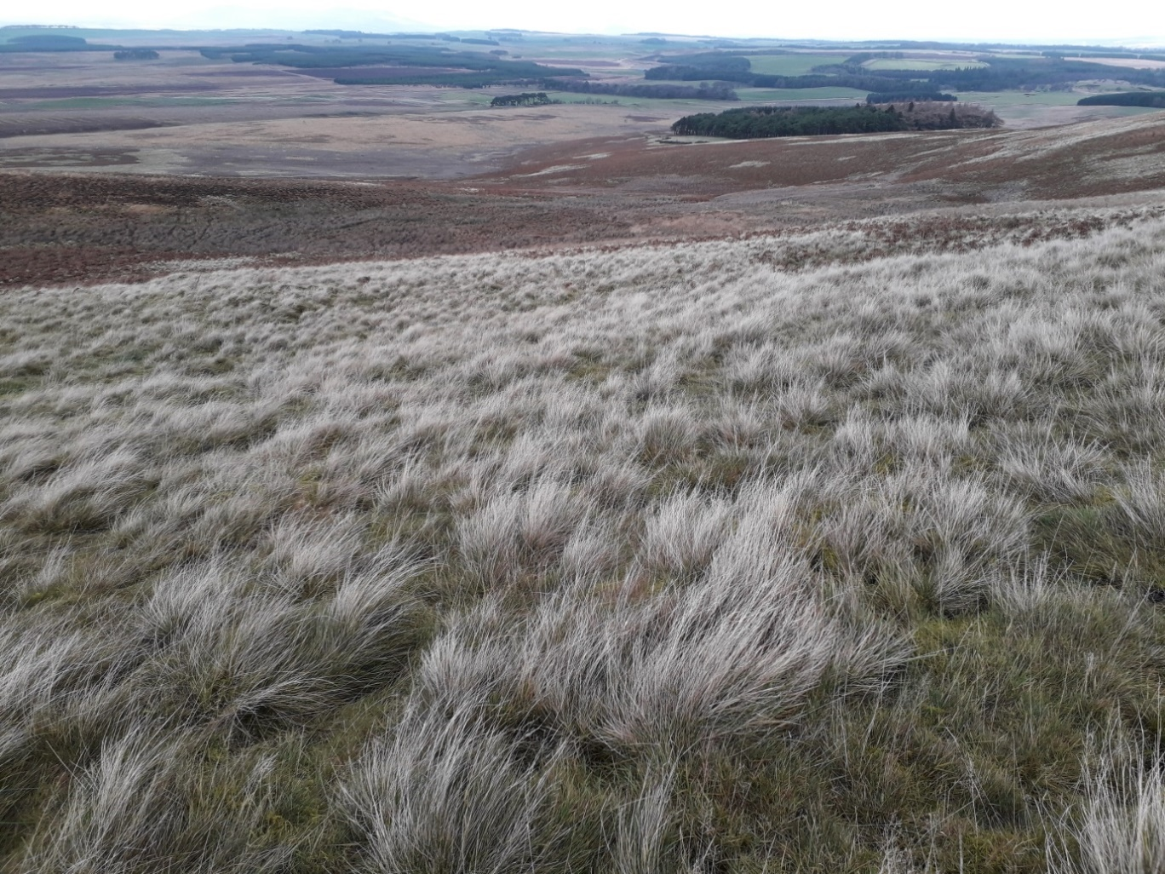
Picture: Moorfoot WC site, taken by Liz Poulsom, SF.

Key messages:
- Early engagement with consultees is required as part of due diligence.
- The design of the woodland must respond to the site features.
- Applications should not be submitted before all of the issues raised through consultation have been fully considered and if relevant, resolved in line with the UKFS.

The working agreement supports this approach which is fully described in SF’s Woodland Creation: Application Guidance and identifies thresholds for engaging the statutory consultees.

Case Summary

Location: Midlothian | Forestry and woodland strategy: Potential
Agricultural land classification: Unimproved 4.1 to 6.3 | Previous Land use:  Sheep grazing – expired tenancy
Primary Management Objective: The establishment of a productive woodland as an alternative to agricultural activity on hill land.
Secondary Management Objectives: Climate change mitigation, Biodiversity, Landscape, Cultural heritage and Water quality.
FGS Option: Conifer | Area: 330 hectares considered.  232 hectares appropriate.
Species breakdown: Main conifer 69.5%, Other conifer 11.5%, Native broadleaves 9%, Designed open ground 10%.

Timeline

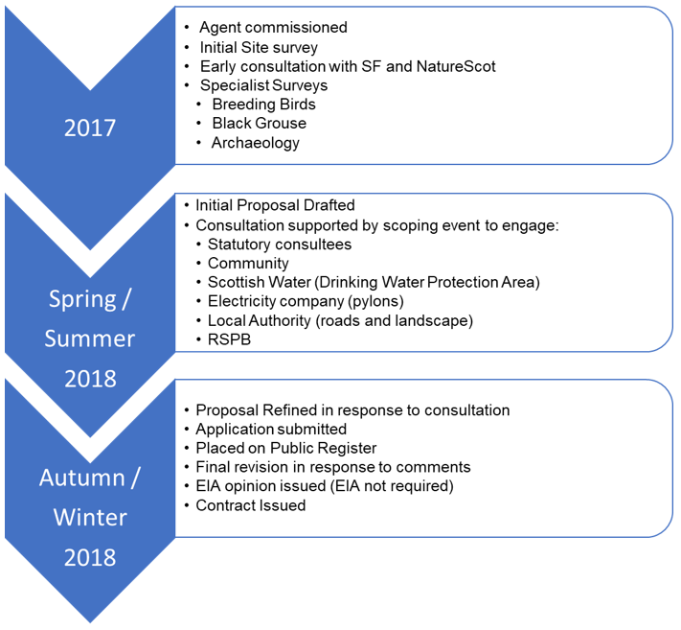

Statutory Consultee Contributions
HES / Local Authority Archaeological Services
This case was not within HES’ remit (see agreement) and instead required the applicant to consult with the Local Authority’s Heritage Officer.

The applicant engaged an archaeologist to survey the site and produce a report which was shared with the East Lothian Council Heritage Officer.

The Heritage Officer identified that the survey didn’t identify the full number and extent of the sites historical and cultural significance, and that some features were not adequately protected by unplanted, UKFS compliant buffer zones.

The applicant addressed this by increasing the buffer zone on the features highlighted by the Heritage Officer and by allowing for a further walk over survey before operations commenced to ensure that the number and extent of all features was clearly defined.

On a learning point, engaging with the Heritage Officer to agree the level of survey, before commissioning this work, would have avoided the additional work required in this case. The Local Authority Archaeological Services teams can also provide a list of contractors that regularly carry out similar work to an acceptable standard.

Guidance and training materials relating to Forests and the Historic Environment can be found here: Scottish Forestry - Historic environment.

NatureScot
The applicant shared their habitats and species surveys and demonstrated how they had been incorporated into their initial design.

NatureScot’s Operations Officer confirmed that the proposal was not likely to have a significant effect on the nearby Gladhouse Reservoir, designation as a Site of Special Scientific Interest (SSSI) and Special Protection Area (SPA) for it’s non-breeding populations of pink-footed geese.

NatureScot’s Officer also welcomed the use of Designed Open Ground in the scheme design to protect Ground Water Dependent Terrestrial Ecosystems (GWDTEs) and to maintain connectivity between historical black grouse leks in line with the Southern Scotland species conservation plan.

Areas of deep peat were excluded from the proposal.

SEPA
SEPA’s Senior Planning Officer highlighted that flood risk for sensitive downstream receptors could be increased. This was addressed in the final proposal by showing that UKFS compliant buffer zones would be applied to all watercourses. The Operational Plan also detailed the various ground preparation methods proposed to ensure runoff would not be increased and the UKFS Forests and Water Guidelines would be adhered to.

The Planning Officer also identified the GWDTEs from the site survey details provided by the applicant, and supported the development of the proposal by identifying the highly ground water dependent species rich areas, that should be left unplanted and buffered, along with those that were not biologically rich, which could therefore be planted.

The proposal to use low density broadleaves and open ground to enhance the upper reaches of the watercourses was supported.

Scottish Forestry (SF)
As well as SF’s Woodland Officer providing support and advice, SF’s Landscape and Cultural Advisor supported the development of a sensitive landscape design in response to the area’s status as a Special Landscape Area.

Other Consultee Contributions
Scottish Water
Confirmed that the site was within a Drinking Water Protected Area and that yield would not be affected by the proposal. SW worked with the applicant to ensure their assets and private water supplies would be protected including agreement on the appropriate use of herbicide and fertiliser (if required).

Neighbours and Community
Private water supplies – flow rates were assessed and protected by appropriate unplanted buffer zones.
Proximity of planting to houses – well-designed open ground used around properties.
Concerns over loss of agricultural land – the estate entered negotiations for alternative land for tenant.

Rural Payments and Inspections Division (RPID)
Confirmed that the land was classed as payment Region 2, which is less productive, therefore there was no significant loss of agricultural production.

Electricity (EON)
Agreed appropriate buffer zone sizes for underground and overhead power lines.

RSPB
Confirmed the breeding bird survey and scheme design in response to the presence of key species was appropriate.

