Equality Impact Assessment (EQIA) Template
Section 1: Details of the policy/practice/project

Information required | Enter information below
Department/Team responsible | Operational Services and Transformation
Name of Policy, Practice or Project being assessed | Improving Accessibility (Business Priority Area, part of the SF Improvement Programme)
Purpose and anticipated outcomes | Make the forestry grant scheme more accessible by creating new guidance and introducing a loan scheme.
Is this a new or existing Policy, Practice or Project? | Three new projects:  - Loan Scheme  - Guidance for Local Authorities  - Guidance for applicants
List of participants in Equality Impact Assessment process | Gareth Phillips – IA Lead  Alasdair Duncan – Digital Business Partner  Amy Noble – Equality and Diversity Manager  Jonathan Taylor – Senior Manager
Date Assessment started | 29/06/20
Completion date | 03/08/21
Who is likely to be affected?  E.g. employees, visitors, contractors, women, men, young people, older people, people with disabilities etc. | Staff: Admin Officers, Woodland Officers, Live Support Officers.  Targeted Customers: Farmers & Crofters  Any of the above that fall within protected characteristics categories.

Section 2: Collecting information
What evidence is available about the needs of relevant groups? Please consider demographic data, including census information, research, consultation and survey reports, feedback and complaints, case law, others knowledge and experience. Please refer to the list of evidence on the EqIA page of the intranet.
Details | Source of evidence
Levels of staff within relevant groups | Equality Mainstream Report:  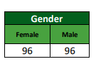  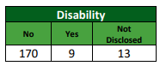  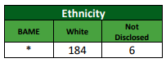  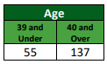  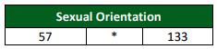  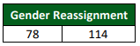  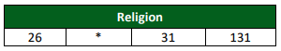  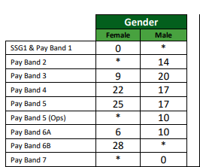  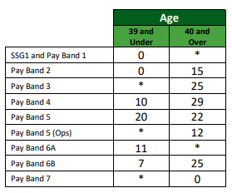
Levels of customers that will fall into ‘disabled’ category | Source: onescotland.org  1 in 5 people in Scotland label themselves as disabled.  Source: Dyslexiascotland.org.uk  1 in 10 people thought to be dyslexic. We know from previous research carried out by partners in the rural sector that those working in land based sectors typically have a higher rate of dyslexia than the average population, so the ratio may be higher for our staff and targeted customers.
Level of targeted customers falling within specific gender categories | Source: Scottish Agricultural Census: June 2018  Majority of farm occupiers in Scotland are Men (58%) and women make up 42%.
Level of targeted customers falling within specific age categories | Source: Eurostat via Farm Advisory Service  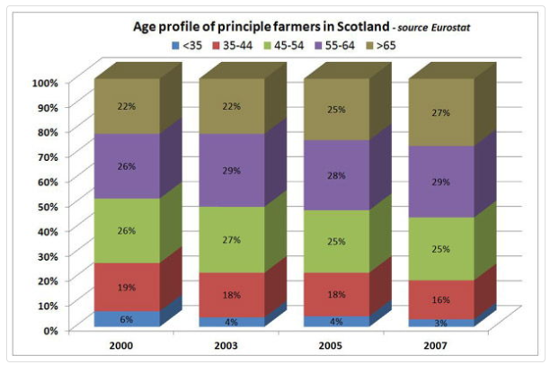

From your research above, if you have you identified any gaps in evidence, enter the details of the gaps below
An assessment of the projects against each of the categories does not appear to yield any negative results.

For staff we do not have 100% declarations on protected characteristics which is a gap in evidence.

Census data is also sparse on most protected characteristics in relation to our targeted customer base (farmers and crofters), with targeted information only being readily available for age and gender within the sector.

Disability statistics are based on the general population however there is no information on whether disability may be more or less prevalent in the farming or crofting communities.

There is no readily available information for our targeted customer base for the following categories:

- Gender reassignment
- Marriage and civil partnerships
- Pregnancy and maternity
- Race
- Religion or belief
- Sexual orientation

Due to the above it is not possible to say categorically that there is no negative impact as the data is incomplete. Any progress and changes within the business priority area will be assessed against these categories to ensure any possible negative impacts are mitigated early, if applicable.

As appropriate, please describe below, the consultation/engagement undertaken, including details of the groups involved and the methods used
SF Improvement Programme board – Representatives from SF Delivery, Development and from Scottish Government. Meets once per quarter to discuss the progress of the Improvement Programme.
Improvement Programme Steering group – Senior colleagues from Delivery and Development. Meets once per quarter to discuss issues and provide policy steers for relevant projects.
Project steering groups – Volunteers from Delivery and the project manager. Normally consists of similar pay-bands with one or two senior pay-bands.
Project working groups – Delivery and Development colleagues who are directly involved in the development of a project, meeting at least monthly to discuss any practical issues related to the projects.
Customer Reps Group – External group of industry representatives who were consulted at the regular meeting on the loan scheme, to give feedback on the proposal and ideas for implementation.
External partner – A crofter was a sounding board for new guidance to ensure it was fit for purpose and accessible for the target audience.

Detail below if there are any other groups to be consulted
No other groups to be formally consulted.
New guidance will be written in accordance with best practice guidelines, such as the Web Content Accessibility Guidelines (WCAG).
The loan scheme is a bolt on for the existing schemes and does not change the existing FGS process therefore no user testing is required.

Section 3: Impacts
Has the research and consultation identified any potential for impacts on those with the following protected characteristics:
Protected Characteristic | Potential Impact (yes or no) | Explain
Age  E.g. older people, children, young people | No | There is no evidence to suggest any of the projects will have an impact on age. Guidance will be available both in online and offline formats so will not be a restriction on age. The FGS process will not be changed by the addition of loans and therefore remains the same.
Disability | Yes | Previously highlighted that our application documents for FGS were not suitable for dyslexic users due to the colour scheme. Revised Operational Plans have been implemented that use pastel colours in line with Dyslexia guidance.  New guidance is being developed as per our brand and communications standards, which includes being in accordance with the WCAG.
Gender reassignment  Where a person is living as a different gender to that at birth | No | There is no evidence to suggest any of the projects will have an impact on gender reassignment.
Pregnancy and maternity | No | There is no evidence to suggest any of the projects will have an impact on pregnancy and maternity. Staff who are on maternity leave and miss the implementation of the new loan scheme will be trained on the process by Conservancy or NO staff on their return.
Race, ethnicity, colour, nationality or national origins  Including gypsies or travellers, refugees or asylum seekers | No | There is no evidence to suggest any of the projects will have an impact on race or the other listed characteristics.
Religion or belief  Including non-belief | No | There is no evidence to suggest any of the projects will have an impact on religion or belief.
Sex/Gender | No | There is no evidence to suggest any of the projects will have an impact on sex/gender. While the target customer base is predominantly male the types of project will not result in less favourable treatment of any group.
Marriage and civil partnership | No | There is no evidence to suggest any of the projects will have an impact on marriage and civil partnership.
Sexual Orientation | No | There is no evidence to suggest any of the projects will have an impact on sexual orientation.

Is there any evidence that the policy may result in any less favourable treatment, discrimination, harassment or victimization as detailed below:
Potential outcome of the policy | Delete as appropriate | If yes, give details of the potential outcome and any project modifications to mitigate the risk
Result in less favourable treatment for particular groups | No evidence | Guidance to be written to ensure it is accessible to customers with visual impairments and/or dyslexia following best practice guidelines.  Guidance to be made available online and offline to ensure it is accessible to all customers.
Give rise to direct or indirect discrimination | No
Give rise to unlawful harassment or victimisation | No

Section 4: Meeting our General Equality Duty
Enter below which aspects of the Policy, Practice or Project seek to eliminate unlawful discrimination, harassment and victimisation
N/A

Enter below which aspects of the Policy, Practice or Project seek to advance equality of opportunity between people who share a relevant protected characteristic and those who do not
New documents and guidance will be written and presented in accordance with good practice guidelines (WCAG & Dyslexia Scotland) to ensure these documents are accessible to dyslexic readers.
Relevant guidance will, where practicable, be produced in both online and offline (hard copy) formats to ensure it is accessible for more customers, particularly less IT literate groups or those with visual impairments that may restrict the use of computers.

Enter below which aspects of the Policy, Practice or Project seek to foster good relations between people who share a protected characteristic and those who do not
N/A

Section 5: Outcome of the assessment
Outcome of the assessment on the Policy, Practice or Project | Enter detail below
No major change
Adjust the Policy, Practice or Project | Minor change in format/presentation of documents to better accommodate dyslexic readers.  Guidance to be made available in both online and hard copies to increase accessibility.
Continue to Policy, Practice or Project
Stop and remove the Policy, Practice or Project

Detail below recommendations, including action required, to address any negative impacts identified
N/A

Section 6: Monitoring
Describe below how you will monitor the impact of this Policy, Practice or Project
E.g. performance indicators used, other monitoring arrangements, who will monitor progress, criteria used to measure achievement of outcomes etc.
Though there will be no formal program of monitoring impacts, there are existing channels for monitoring feedback from:

- Operational Delivery (NO and conservancy staff feedback) through regular meetings.
- Customers (Media team through social media etc.)
- Industry bodies (through Customer Reps Group meetings).

It is expected that any apparent or emerging negative impacts will be fed back through these channels and adjustment made where required.

When and how is the Policy, Practice or Project due to be reviewed?
Each project will be subject to active review after the full implementation of each and changes made based on feedback once the project outcomes are embedded into existing processes.

Section 7: Sign off
Required information | Enter information below
Date sent to Equality and Diversity Manager
Comments from Equality and Diversity Manager | Amy Noble – E&D Manager
Date signed off by Equality and Diversity Manager | 3/8/21

Details of Senior Manager who has signed off this Equality Impact Assessment | Enter information below
Name | Jonathan Taylor
Title | Head of Executive Office
Date approved | 3/08/2021
Please send this completed and approved Equality Impact Assessment to:
Amy Noble, Equality and Diversity Manager, Forestry and Land Scotland

