Adaptation and Resilience Steering Group – March 2024
Note of meeting – Final

Attendees:
Chris Quine (CQ), Forest Research
Andrew MacQueen (AMQ), AM Silviculture
Andy Leitch, Confor
Duncan Stone (DS), NatureScot
Andrew Weatherall (AW), RSPB, Scottish Environment Link
Alan MacDonnell (AMD), Trees for Life
Kevin Reid, Tilhill
Alan Hampson (AH), Scottish Forestry (chair)
Helen Sellars (HS), Scottish Forestry
Tim Gordon-Roberts (TGR), Scottish Forestry

Guest speaker: David Edwards (DE), Research Impact Coordinator, Forest Research (FR)

Apologies:
Nathan Bryceland, Scottish Land and Estates
David Leslie (DL), James Jones & Sons
Craig Turner (CT), Confor Nursery Producers Group
Jo Ellis (JE), Forestry and Land Scotland

Introduction (AH)
The main aim of this steering group meeting is to provide an update on the future productive species project and gain input into the criteria prior to the workshop.

Action points from last meeting (HS)
Feedback from the papers presented at the last steering group – closed.

RAP update (HS)
Steering group 1:1 discussions on the 1st draft of the Resilience Action Plan are underway, in particular these discussions will focus on if and how the Plan could be developed any more in these areas:

- Strategic planning – national, regional and local levels
- Learning from Europe
- Tree Health
- All woodland types
- Biodiversity – also to be enabled by feedback form the National Stakeholder Group

The time-line for publishing the RAP is being considered along with Scottish National Adaptation Plan (SNAP3) as the two outputs are strongly linked (SNAP draft timeline for publishing is Autumn 24). The Steering Group will see a further draft of the RAP before publishing.

Future Productive species update (HS)

A large amount of work has been done and the purpose of today is to update the group on that work, and gain input on the criteria in advance of the next workshop. We will also continue discussions with steering group members and other’s they suggest, on specific criteria, to ensure all relevant expertise has been included in the considerations and analysis.

The workshop is now the end of May – following that there will be a period of review and then this project will be brought back to the SG after summer.

It was suggested that the delay with the workshop could also offer the opportunity to consider the outputs from the Diversitree project. DE shared that this is already included.

Future productive species choice project update – methodology (DE)

The 8 initial criteria identified at the September 2023 workshop and the following analysis by Forest research have held up well and provided strong base for the project.

DE talked through the Criteria table and showed some of the detailed data gathering and analysis used to produce the table.

Scores / ratings are based on a thriving tree – well matched to the site / climate and well managed in line with UKFS. All criteria and initial results will need to be sense checked before publication. Confidence scores are to be provided for each criteria.

Tree improvement – Subject Matter Expert (SME) consulted to date - Richard Whittet, who has provided an extensive commentary on most of the 60 species. This is a large volume of information which is now being structured to allow for consistent assessment of each species.

The data is falling into two main attributes - factors of the tree itself and the stage of tree improvement. The intention is to combine these to give an overall score of ‘tree improvement prospects’.

The steering group discussed the following:

If the data collected is a function of the past, could this give a bias towards business as usual?

The idea is that the data is forward looking – prospects for tree breeding – to do this there is a need to identify where we are now and then how each species could be taken forward – identifying what the next steps in tree improvement would be and what the ultimate goal for that species would be.

Other studies are looking at assisted migration and suitable provenance – is this approach too focused on Scotland now?

Some data is based on GB level but looking for a Scottish answer – for example; how well known and considered / resourced is it in Scotland – do we know enough about it in Scotland. There was a question on whether we should be looking at species from England.

It was considered worthwhile looking at the area planted in the UK to cover this aspect.

Action - DE to ask Richard Whittet if the output for tree breeding could be improved by considering the area of each species planted in the UK.

Plant and seed supply
SMEs consulted to date – Chris Hardy (Head of Centre for Forest Management, Forest Research), Selchuk Kurtev (Zest Sustainable ICM)

Produced a database with 8 attributes.
Most important attribute is seed supply (availability), therefore this has been given a 50% weighting, with the other 7 attributes given an equal weighting across the remaining 50%. The total scores have then be aggregated and given a Red, Amber, or Green (RAG) rating. Commentary has been provided for notable issues.

A meeting is to be set up with nursery representatives to discuss approach to this criteria.

Silviculture
SMEs consulted to date – Andrew Leslie (Head of Silviculture & Wood Properties, FR), Chris Reynolds (Project Leader - Silviculture and wood properties, FR), Tor Stokes (Silviculturist, FR), Tom Ovenden (Scientist - Silviculture & Species, FR), Bill Mason (Emeritus Silviculturist (Research Fellow), FR).

Strongly linked to site / climate suitability and productivity.

3 main attributes agreed so far:
- silvicultural knowledge score – amount of research, how much is grown, how much published science.
- establishment rate – tree size at 5 years turned into score 1 – 3. Could be used as a proxy for establishment cost.
- palatability – scored 1 – 3.

Non-definitive attributes include:
- suitability for non-uniform silviculture (term to be reconsidered – continuous cover?). This includes shade tolerance for which data is available.

This data has been considered to be non-definitive because a species shouldn’t be excluded / included because of it’s growth strategy – light demanding / shade tolerant, because we will need a range of species with different growth strategies to suit a range of silvicultural systems from clearfell and restock (which favours light demanding species) to continuous cover (which will require shade tolerant species).

Comments were made that this is about the versatility of the species to a range of different silvicultural systems.

Action - DE to explore and include if feasible mixtures as an attribute.

A dataset has been produced for this by FR which can be considered: https://www.forestresearch.gov.uk/publications/establishing-robust-species-mixtures/

Climate suitability
SMEs consulted to date – Stephen Bathgate (Software Developer, Climate change, FR)

Does the species grow in Scotland and will it continue to grow in a changed climate. Scored by the percentage of land that a species is suitable for now and in 2080, using ESC.

Climatic suitability will be shown separately from site suitability because climatic data in ESC is based on means, giving an over estimate of suitable area (areas of suitability are reduced, sometimes significantly, when climatic extremes, like drought, are factored in). Whereas site suitability tends to be an underestimate of actual suitability due to the lack of information on site factors like topography and the large scale used for soil data.

Both factors will be used to give an overall score.

The results are not to be used for operational decisions and should only be used for broad strategic assessment.

Action – DE to investigate how ESC deals with the uncertainty around the climate change projections, to explain this in the workshop.

Climate suitability - Abiotic risks
SMEs consulted to date – as per Silviculture

Drought, frost, wind have been scored.

Exposure (to desiccating winds) to be discussed.

Discussion points as follows:

Should tolerance/ susceptibility to wildfire and flooding be assessed? Flooding is hard to assess and is based on local site issues, but tolerance of waterlogging / ability to cope with broader fluctuations in water tables, would be useful.

Fire risk is increasing – should flammability be included?

These are all serious risks but does the assessment become too big and stop working if you include every risk. All trees are susceptible to something so it will be better to prioritise the key risks.

Many of the risks can be mitigated against by management – don’t plant frost sensitive species in frost hollows etc. All the information gathered is needed to choose species and for deployment of those species but not necessary for this assessment.

Drought tolerance should also be linked to thirstiness – negative impact on the water environment by taking too much water.

Action: DE to review data on water usage: https://www.forestresearch.gov.uk/research/forestry-and-water-resources/

Productivity and Carbon
SMEs consulted to date – as per Silviculture plus Robert Matthews (Science group leader, Mensuration, growth and yield, FR), Euan Mackie (Research Forester, Mensuration, growth and yield, FR).

Assessed using Yield Class (YC) models.

Action: DE to update data to use the new yield models.

Linked to carbon – YC, rotation length, wood density – assessment to be considered for carbon.

It was asked if there is any data available for species and soil carbon.

Action: DE to check. This will be shown as a caveat for the carbon score if not.

Pests and diseases
SMEs consulted to date – Sarah Green (Forest Pathologist, FR), Katrina Dainton (Research Entomologist, FR), Clarinda Burrell (Tree Health Policy Advisor
Scottish Forestry (SF), Flora Donald (Tree Health Policy Officer, SF).

Pathology and entomology have been considered separately.
Commentary has been provided by FR’s subject matter experts based on their knowledge and experience, separated out into current and future risks with a RAG rating. These preliminary results were then further scrutinised and expanded by Scottish Forestry’s Tree Health team using the Plant Health Risk Register.

The current RAG definitions were given as:
Red: The species would be killed or so severely debilitated that the forest would become unproductive.
Amber: Under certain circumstances, the species could be killed or so severely debilitated that the forest would become unproductive. For example, if it was exposed to a high inoculum load due to proximity to an infected stand, or suffers from abiotic stress due to planting on a drought prone site. The risks could be mitigated through careful planning and management.
Green: Based on our current state of knowledge, there is no apparent reason why the species couldn’t be promoted as a plantation species.

The FR pathologists raised a particular concern with the potential risk of introducing / using exotic pines, as they could bring in novel pathogens that could threaten native Scots pine woodlands.

Focus now will be to review the species with red scores and to test the RAG rating more widely.

Deer, small mammals, grey squirrels – work is in progress to see if we can add a meaningful score for these and to work out if resilience / tolerance helps to separate out the species or if these factors are more about appropriate management to mitigate any negative impacts.

The group viewed the assessments for Norway and Sitka spruce, both are currently scored as green for pathology and amber entomology (Ips typographus).

Biodiversity and environmental impact
SMEs consulted to date – Nadia Barsoum (Senior Forest Ecologist, FR), Alice Broome (Senior Scientist - Priority species/ habitats, FR).

This is the least developed to criterion to date. The approach agreed so far has been to identify species traits which have an impact on the surrounding environment, such as; soil chemistry, water, shade etc.

Invasiveness is included as an attribute but a suitable dataset is still to be identified.
The group discussed if invasiveness can be managed by adherence to UKFS requirements. Others thought that it would be good to include invasiveness as there currently appears to be a lack of resource to manage this issue.

Action: DE to consider

This criteria could also be linked to water / drought / thirstiness as discussed earlier.

Some attributes will not be a function of the species itself and therefore if just about management then they shouldn’t be included. The data for direct measures of species associated with trees is very patchy

The results will also be checked with the Diversitree project. If there isn’t a full data set, it can still be provided as background data.

Nativeness score – scale based on native or if non-native how long it has been established in UK.

The group discussed the issue of species that are native to Scotland / UK – species previously seen as native in England and not in Scotland may now be candidates for future native woods in Scotland.

Species classed as near native (those that would have established in Britain if the land bridge to the continent had remained) should be considered.

Definitions of Archeophyte and Neophyte were explained as they are being considered as potential attributes / criteria.

Archeophyte - non-native (alien) taxa that were introduced by humans, either intentionally or unintentionally, and became naturalised in Britain and Ireland between the start of the Neolithic period and AD1500.

Neophyte - The rediscovery of the New World around AD1500 brought about radical changes in human demography, agriculture, trade and industry. It therefore marks an appropriate date to differentiate between ancient and modern introductions; those introduced before AD1500 were usually associated with food production whereas those that came after (neophytes) are mainly garden ornamentals and trees used for forestry.

See: Archaeophytes – Botanical Society of Britain & Ireland (bsbi.org)

It was agreed that this criteria would benefit from further in depth discussion with interested members of the SG.

Action: TGR Meeting to be arranged to discuss this criteria with DS, AMcD, AW.

Timber quality and end use
SMEs consulted to date - Elspeth McDonald (Senior Scientist - Tree & Wood Properties, FR), Dan Ridley-Ellis (Head of the Centre Wood Science and Technology, Edinburgh Napier University), David Leslie (Joint Managing Director, James Jones & Sons Ltd.).

Initial data was prepared by FR and now passed to Dan Ridley-Ellis to return a draft for the 26th March.

In depth discussions held with DL – sharing insights on what properties are important to processing sector and structural factors at play that are limiting diversification.

Initial criteria include the maximum product value (the best you can get out of the timber), which is to be considered alongside market demand, this will help to differentiate between species that produce high value products but of low volume opposed to a high volume.

Considering combining some of the data to give a score for similarity to SS. It was highlighted that this is particularly important for volume production. Volume is covered by Y/C. Sitka is possibly twice as productive as any other. There was a question on how big an area would be needed to replace Sitka?

It was suggested that further work may be needed to estimate what scale is wanted / needed for future supply / demand. This could be addressed through the Resilience Action Plan which proposes looking at future market supply and demand.

Currently it is considered that there are two markets that reflect the main volume flows – white wood and all other timbers. Whilst recognising this is the case now, it will be important to avoid presumptions that lead to the exclusion of other species / and stop people from trying other things.

A significant emerging and potentially significantly market appears to be based on deriving hemicellulose for bio-products – this will favour species that this can be best derived from.

There will be a need to amalgamate attributes to produce final criteria, but it will be necessary to retain the back ground data to help deploy other species and identify any research gaps. Need to future proof the list in terms of current and future end uses. May need a short list for strategic purposes and a longer list for owner/manager choices to deploy species.

Summary
This work analyses the attributes of 60 species and considers how to judge them against each other. The challenge is to agree how we use the datasets to get to a short list.

One potential solution is to apply early filtering – for example; species that have a red score for pests and diseases or low productivity, could be excluded to provide a medium list for which we could get a complete dataset, which is then assessed in more detail. Consideration also needs to be given to weighting – should all criteria be equal or are some criteria more important than others? These could be explored at the upcoming workshop with careful consideration.

Use at UK level
To inform the project, previously completed, similar work in the UK, was reviewed.
As the project develops, the interest at a UK level has significantly increased. Much of the data gathered can be used or easily adapted to provide a UK assessment.
Actions to take forward the short list species may be better done at UK level to combine resources. Many of the large scale companies operate across the UK, and across many aspects of forestry from nursery production, forest management through to timber harvesting and processing, so this is of significant interest to them at a UK scale.

Workshop agenda
DE suggested some themes and exercises to enable the criteria and results to be understood and to introduce the concept and impact of weighting at the workshop.

Action: The SG were asked to consider how to disseminate the information gathered and how to get the wider sector behind a short list.

Knowledge Exchange Events (TGR)
The KE events shown in the table below were discussed briefly.

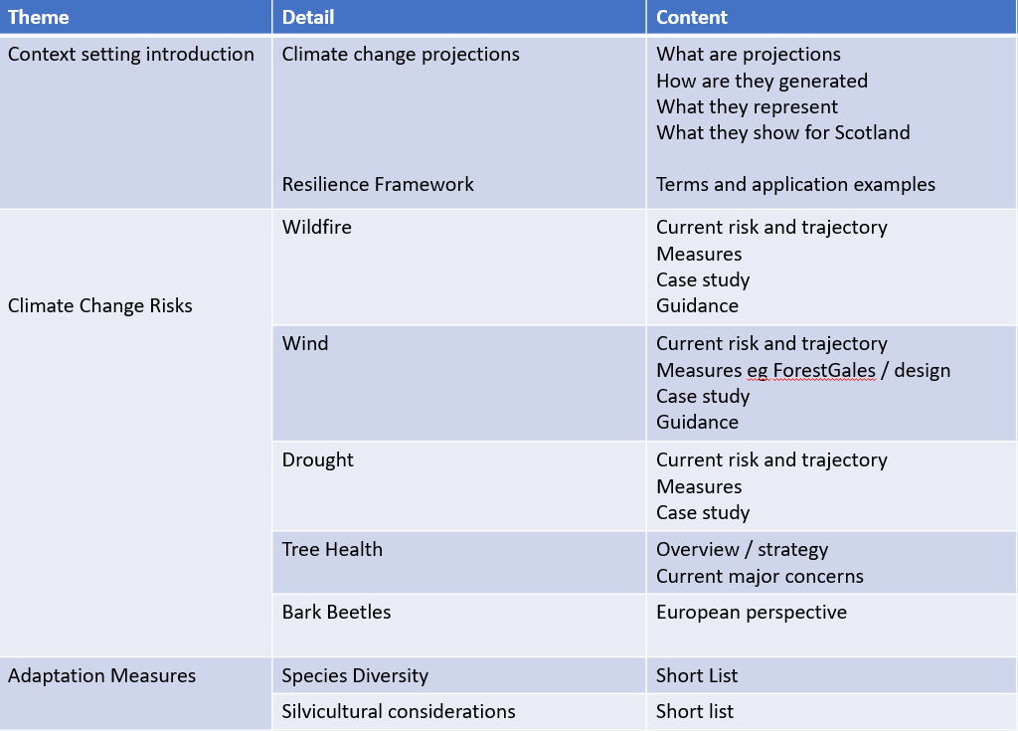

The SG agreed that it would be important to be clear on the scope, context and purpose of the events when promoting them.

These events need contexting and a health warning as people maybe expecting a recipe for resilience so need to be clear what these are. Caveat the events ‘ie this isn’t going to tell you how to ‘do’ resilience’.

The following suggestions were made for additional events:
- future fibre demand
- nursery production

Summing up (AH)
Alan thanked everyone for a full and productive meeting and looked forward to seeing everyone at the workshop in May.

