Adaptation and Resilience Steering Group 1 - Note of meeting
30 August 2023 10:00 – 12:00: Teams meeting

Attendees:
Chris Quine (CQ), Forest Research
Andrew MacQueen (AMQ), AM Silviculture
April Armstrong (AA) deputising for Andy Leitch, Confor
Craig Turner (CT) deputising for Harry Frew, Confor Nursery Producers Group
Jo Ellis (JE), Forestry and Land Scotland
Duncan Stone (DS), NatureScot
Andrew Weatherall (AW), RSPB, Scottish Environment Link
Kevin Reid (KR), Tilhill
Alan MacDonnell (AMD), Trees for Life
Liz Walker (LW), Biodiversity Programme Manager, Scottish Government
Alan Hampson (AH), Scottish Forestry (chair)
Helen Sellars (HS), Scottish Forestry
Tim Gordon-Roberts (TGR), Scottish Forestry

Apologies:
David Leslie (DL), James Jones & Sons – points raised shared in the meeting.

Purpose of meeting
This was the first meeting of the Steering Group (SG or ‘group’). The purpose of the meeting was to agree the terms of reference for the group and to consider priorities for action to support implementation of resilience and adaptation measures.

- Terms of Reference (ToR)
The Steering Group’s role is to implement the objective and priority of Scotland’s Forestry Strategy to increase the resilience and adaptation of our woodlands and forests to maintain and enhance the benefits they provide.

The group discussed the content of the ToR and agreed that there should be a focus on identifying practical measures. There was a wide recognition of the need to act, but a lack of action to date because of the uncertainty of what to do, and how, where, and when to act.

It was acknowledged that adaptation and resilience is an expansive topic therefore the group will need to clearly define the scope of what the group will address.

In recognising the uncertainty over just what is a ‘climate resilient forest’ it was accepted that part of the group’s role will be to advise, advocate for and to undertake actions that are most likely to enhance the characteristics which help make forests more resilient e.g., more diverse. Working together to develop and implement actions has the most chance of being successful in achieving the aim of the group.

SG Membership
The group identified the following gaps in steering group membership:
- Landowner / investor – invite to be extended to Scottish Land and Estates.
- SG Green recovery / skills / land use– to be considered

It was noted that SF’s intention was to enable group size to facilitate active discussion, so that would also be a consideration in any additional invites.

Action – Helen/Alan

Links to other groups
It was agreed that it would be useful to map relationships to other groups / activities, for example:
- DS links to NatureScot’s adaptation and resilience planning,
- DS and CQ link to the plant health centre,
- KR has links to SG’s skills development work

Action - Tim

- National Stakeholder Group – Building resilience paper – refresh (HS)
HS had developed thinking on Building Resilience and written a comprehensive paper to bring some structure to this expansive issue and set out the strategic and practical aspects as follows:
- The strategic context
- Defining resilience (4 aspects; resistance, adaptation, response and recovery).
- Why we need to build resilience: impacts
- What we need to build resilience to: threats
- How to build resilience: practical measures (incl. assessment in an Annex)
- The discussion covered issues such as:
  - scale – resilience can be implemented at a national, landscape, or local level
  - Balance of SFM benefits
  - Timescales
  - Planning and management
  - Location and objectives
  - Uncertainty
  - Investment
  - Monitoring and surveillance

This paper had been discussed during development with a range of stakeholders, and at a number of stakeholder meeting including the National Forestry Stakeholder Meeting (Ministerial level) - a large number of this group had been involved in one or more of those discussions. The paper and a note of the meeting are available on the SF website.

HS recapped on the main points from the paper and highlighted that the aim of the Steering Group is to move on from those discussions to identifying priory actions and how we could collectively deliver.
Need to build on the table in Annex 1, which sets out the practical measures that can be taken, and turn the opportunities and constraints outlined in that table into prioritised actions.

- Exercise 1: Resilience measures and the forest stages
Steering Group members had individually completed a table showing the relevance of resilience measures to the stages of the forest cycle. Responses had then been averaged to give overall SG scores for relevance.

The table with overall SG scores in included as Annex 1 at the end of this note.

This exercise highlighted the planning stage as scoring highly. SG members supported identification of this as a priority.

- Exercise 2: Identify the drivers and enablers to implement the measures.
The SG was asked to suggest what we, as a collective across research, policy, and delivery can do to enable adoption of the measures for each stage of the forest cycle. The SG voted for the most important, results are shown below in Annex 2.

Knowledge exchange, species choice and training and guidance scored highly.

- Discussion:

The discussion identified that species choice was a key priority. There was a discussion around uncertainty around what alternative species we should plant and the risk to those, compared to Sitka. Economics was also raised and the need for analysis around cost and risk. Concerns were raised that doing the wrong thing will result in stressed trees / may increase pests and diseases.

It was recognised that this can be a point of failure in delivery – forest plans may specify diverse species but a lack of availability, skills, knowledge and experience in planting them can mean desired outcomes are not delivered

Forest Planning was also identified as a key priority – it was highlighted that it was a big topic, of which species choice is a part. There may be a need for structured modular online training.

Knowledge exchange on research and practical experience was also identified as a priority. This could be done by site visit or video demonstration.

More training and guidance was also identified as a priority. A need to be cognisant of time and make advice easily and quickly available.

A need to get investors engaged was also discussed.

Next steps and close

Species choice, Planning, and knowledge exchange including training and guidance, were identified as the key initial priorities for this group to take forward.
SF have started planning a species choice workshop as this was identified following discussions at the National Forestry Stakeholder meeting. Following that SF will combine the outcomes of this meeting and that workshop and it bring back to this group.

Action - SF

Date of Next meeting – to be agreed by doodle poll aiming for end Nov / early Dec (already circulated).

Annex 1.

Results from exercise 1:

Table 1 showing the overall SG scores for the relevance of adaptation measures (taken from UKFS Practice Guide – Adapting forest and woodland management to the changing climate) to forest cycle stages.

Relevance:
Low
Medium
High

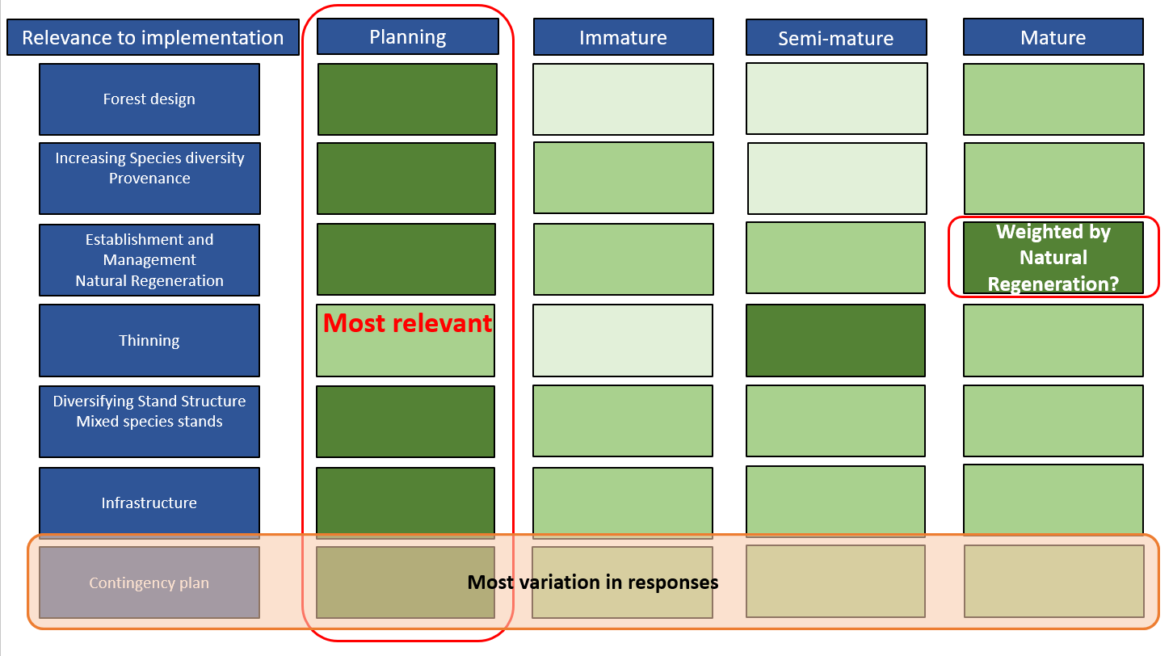

Annex 2.

Results from Exercise 2

Driver / enabler | Total
Knowledge exchange / sharing empirical evidence / dialogue | 7
Species diversity | 7
Training / clear guidance | 6
Reduce deer populations | 5
Landscape scale | 5
Trial plots (new or historic) that can be freely viewed / Demonstration sites | 4
Natural regeneration | 4
Climate refuge | 3
Collective working | 3
Diversify silviculture | 3
Grant conditions | 3
Identify research gaps | 3
Native / natural | 3
UKFS | 3
Hardwoods | 2
Increase CCF | 2
Planning | 2
Biosecurity | 1
Brown earths are diversity not yield class opportunities | 1
Consider resilience of non-tree components | 1
Tree components | 1

